Youth-Led Creativity Funding
Guide
Part 1
About the fund
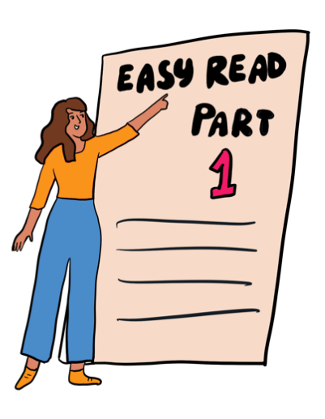 | This is the Easy Read version

Youth-Led: this means work that is led by and for young people.
Fund or funding: this means money that we give to organisations to support them with their programmes.

Who we are
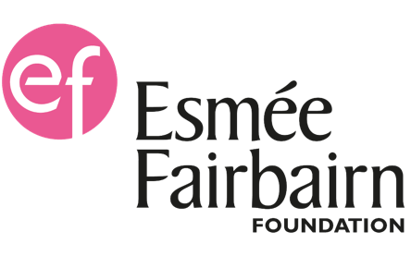 | We are Esmée Fairbairn Foundation. We are an organisation that gives out funding – for example, we give grants to other organisations.  We give out funding to push for a better natural world and a fairer future. We also give out funding to make communities stronger across the UK.
Grant: this is an amount of money that we give to an organisation, to support them to carry out a programme.
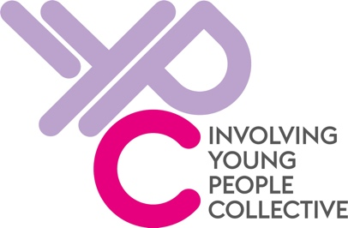 | We have worked with young consultants from Esmée’s Involving Young People Collective.
Involving Young People Collective: this is a group of young people who are connected by their drive to push for social change. They work with us as consultants to improve how we work.
Consultant: a person who gives expert advice.

About this document
 |  | This document has information about the Youth-Led Creativity funding programme.  It talks about the aims of the programme and if your organisation can apply.
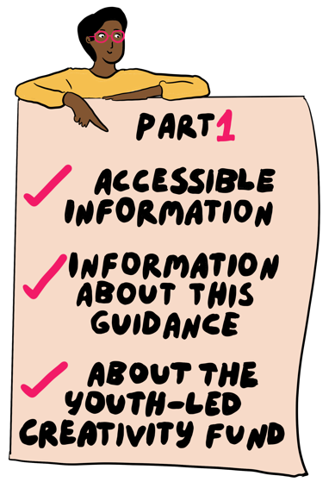 |  | This is Part 1 of 2.  It covers these sections:  - Accessible information  - About the Youth-Led Creativity funding and criteria  - How we make decisions  Please go to Part 2 when you have finished this part.

Accessible information
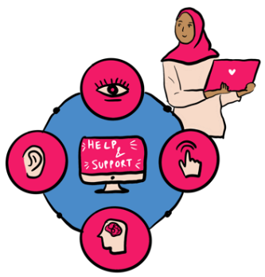 |  | Please tell us if:  - You want this information in another format that is more accessible for you
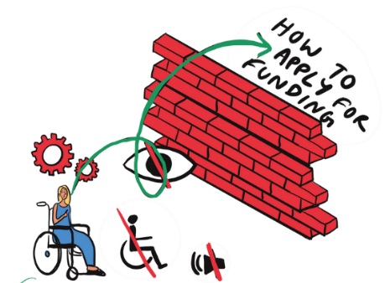 |  | - You have a problem with the application process  We will do our best to support you to apply in a way that meets your needs.
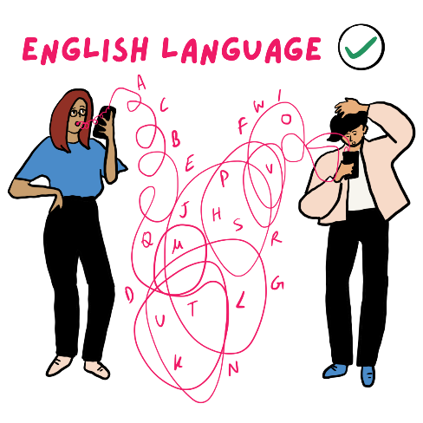 |  | We can only accept applications in English. But if you need help with translation, we can help with the cost for this. For example, with translating from BSL (British Sign Language), Welsh or another language.
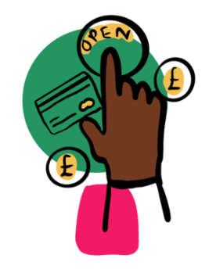 |  | We can also give an Access Payment to help with accessibility. This is money that pays for support to apply.  You can learn more about our accessibility support on our website here.
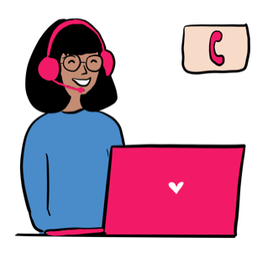 |  | You can email us at this address:  communications@esmeefairbairn.org.uk  Or, phone us on this number:  020 7812 3700

About the programme
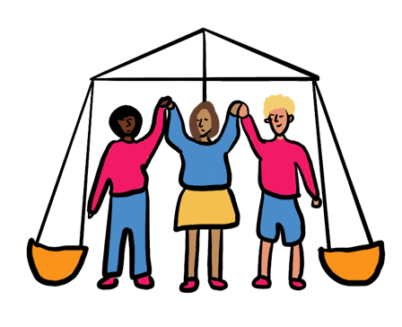 |  | The Youth-Led Creativity programme builds on young people’s power to make change.  It is part of Esmée’s work to make sure there is a fairer future.
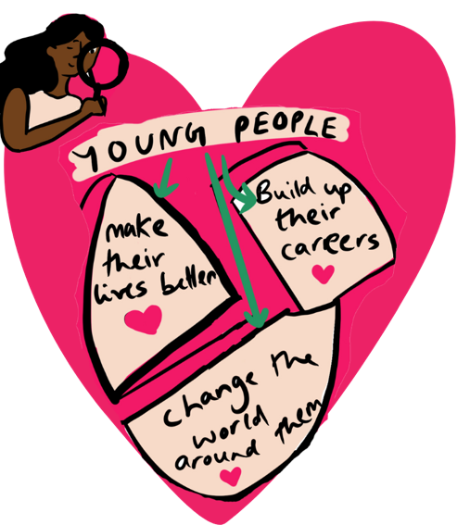 |  | The programme uses being creative to support young people to:  - Make their lives better  - Help grow their careers  - Make change in the world  So, we want to give money to young people to help them do this.
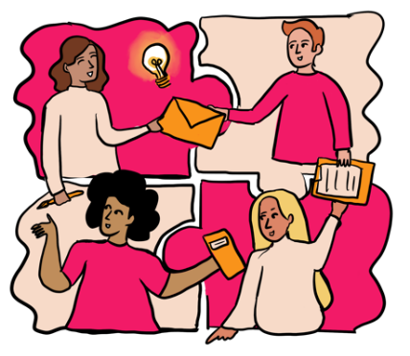 |  | The programme has been co-designed with young consultants.  They will play a big role in looking at your applications.
Co-design: here, this means working with young people to design programmes and make decisions that affect their lives.
 |  | The Involving Young People Collective will lead the assessment of applications, with support from Esmée staff.  This is to make sure the views and voices of young people are a big part of the programme.
 | An assessment is a review of information.
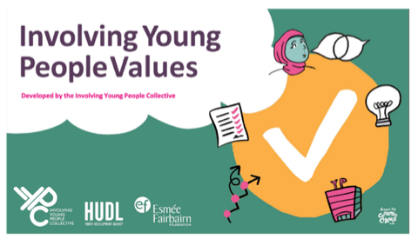 |  | We will also use the Involving Young People values when making decisions. You can read them here: Involving Young People Values
Value: this means an important belief or standard.

About the funding
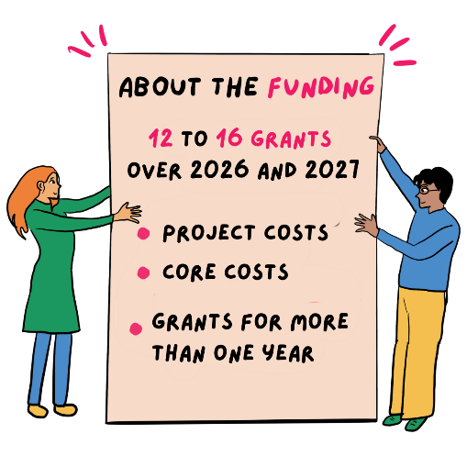 |  | We will make about 12 to 16 grants over the next 2 years. We can give grants for  - Project costs  - Core costs (like staff salaries and office rent)  - Costs for more than 1 year
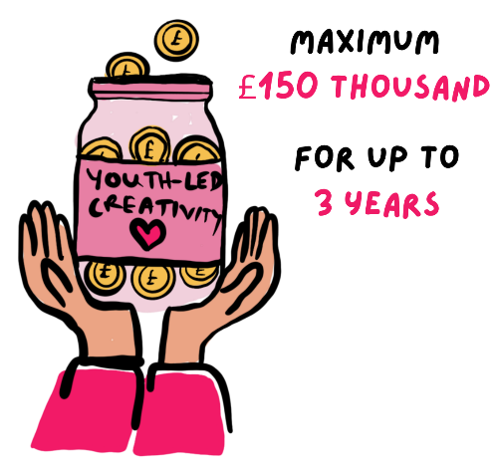 |  | The most money you can apply for is £150 thousand.
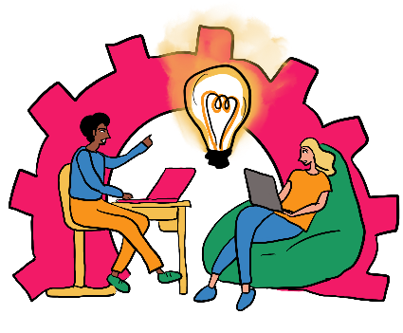  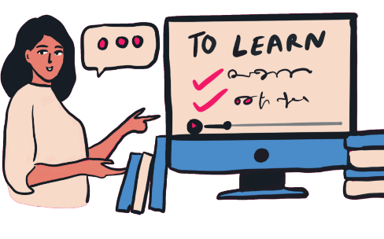 |  | There will also be a Learning Programme where:  - Organisations can learn with and share how they work with other organisations we are funding  - Help us to support organisations better in the future.  A Learning Partner will help to run the programme. This is a person who supports an organisation or group of organisations to learn.
 |  | Organisations will be paid to support them to take part in the Learning Programme.

The criteria

Criteria: this means who and what the funding is for
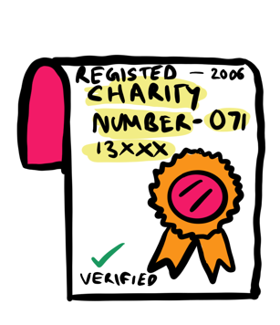   |  | Who will we fund  - These are the types of organisations we will fund:  - Charities  - Community Interest Companies  - Community benefit societies  - Social enterprises (businesses for social good)  If you are not a charity, we will want to know what your organisation does to stop people getting personal benefits from your organisation.  This means for example, someone getting money or free items to use for themselves. Some organisations call this an asset lock.
Asset: this means anything that your organisation owns that has a high money value. For example, cash, buildings or cars.
Asset lock: this means an agreement that funds must only be used to serve the communities that your organisation supports.
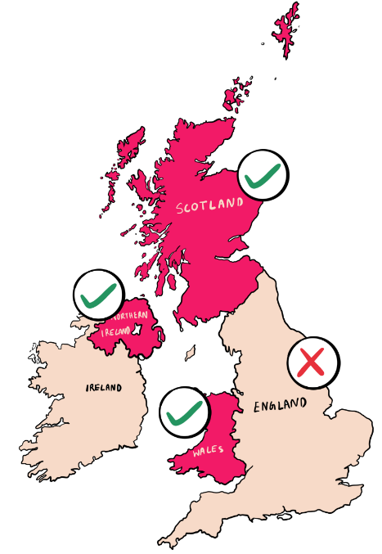 |  | - We will fund organisations based and working in:  - Northern Ireland  - Scotland  - Wales
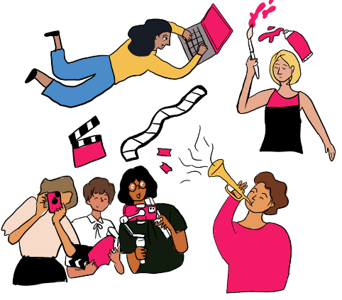 |  | - We will fund organisations that mainly do arts and cultural activities
 |  | - We will fund organisations with a yearly income of over £50,000 (50 thousand pounds)
Income is the amount of money an organisation has coming in. This could be from sales or giving services. It could also be from things like grants and investments.
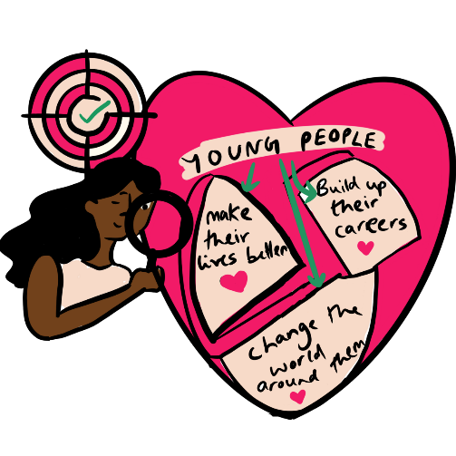 |  | What kinds of work we will fund:  - Helps young people to make change by using art and being creative.  Examples include:  - Being open to new ideas about what youth-led creativity can be.  - Using art and creativity to make change led by young people.  - Helping young people become creative leaders, artists and change-makers.

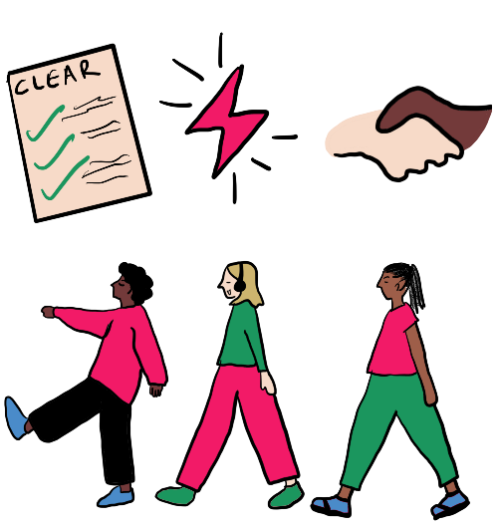 | - Young people lead. They have the power to always make the big decisions, plans and actions. Adults support the young people and share power only when needed. The young people supported are aged 14 to 30. Examples include:  - Decisions are made with young people in a fair and open way.  - There are clear agreements about how to share power.  - Young people are given real power, with training and support.  - Trying new and different ways for young people to lead.
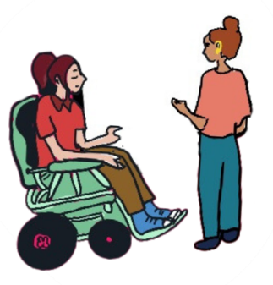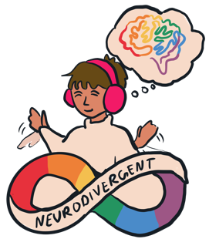 | - Focuses on under-represented young people. This means work that involves young people from communities you don’t see often in arts and culture. This includes:  - Deaf people  - Disabled people  - Neurodivergent people
Neurodivergent means people who think differently, for example, people with autism.

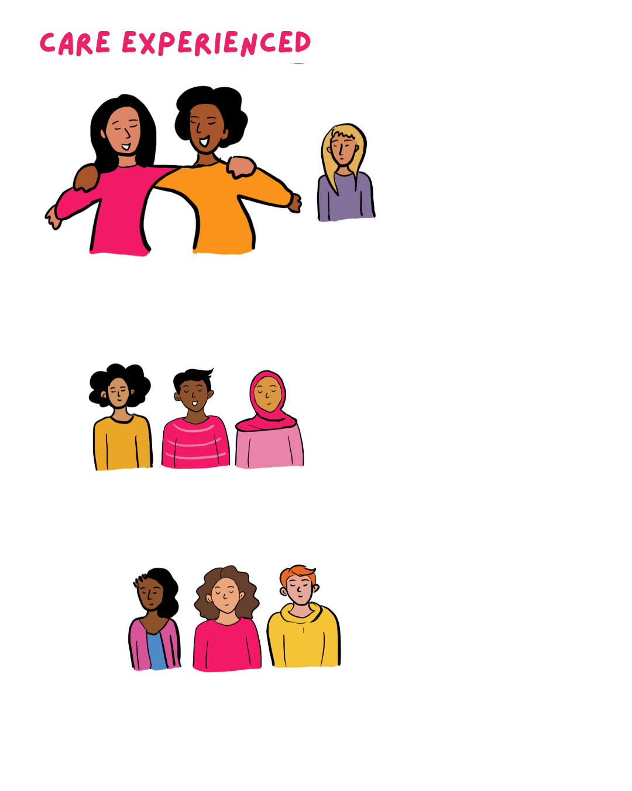 | - People from communities that who can get treated unfairly because of their race
 | - People who are at a disadvantage because they don’t have lots of money
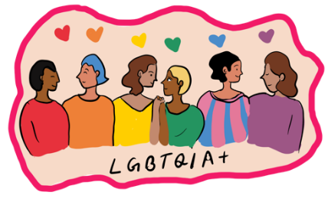 | - People who identify as LGBT+
LGBT+: stands for Lesbian, Gay, Bisexual, Transgender, and other people who don’t meet traditional roles around sexuality and gender. They often face barriers because of who they are, and who they love.
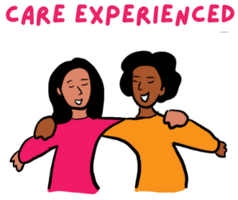 | - People who have experience of being in the care system.
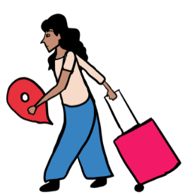 | - People who have experience of migration.
Migration: this means people who have come to the UK from another country. Often, this is to escape danger or to have a better quality of life.
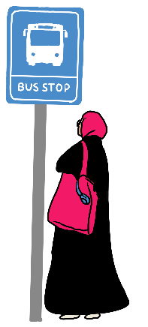 | - People who live outside of a big city
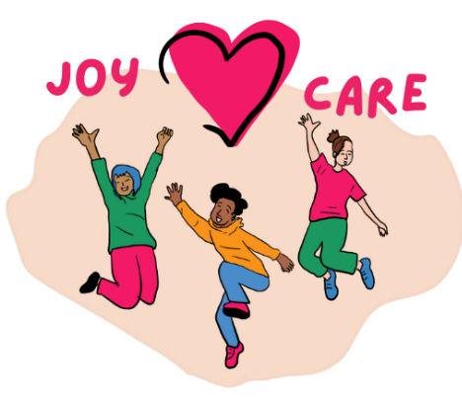 | - Puts the joy and care of young people first.
Joy here means feeling happy, safe and connected with other people. It happens when people feel valued and free to be themselves.

Care here means working together with kindness and respect. It means understanding that people have different needs and experiences. It also means putting people’s wellbeing first, including their mental, physical and emotional health.
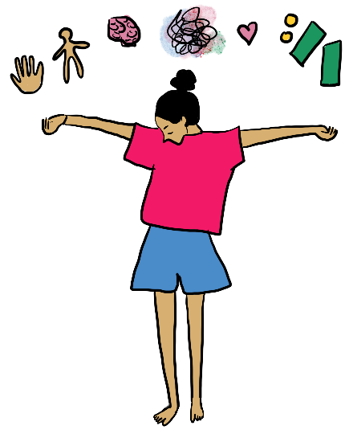 | Examples include:  - Showing that care and joy are important and led by young people.  - Thinking about all parts of wellbeing, including body, feelings and money.  - Supporting young people as whole people, not just by what they do.  - Making space for hard talks, different experiences and real connection.  - Showing that fun and time together matter, without needing special aims or results.  - Bringing joy and positive energy into the work.
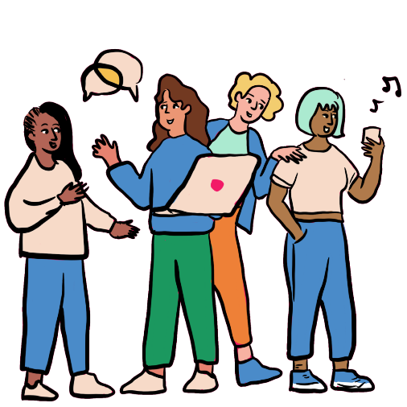 | - Works and learns with other organisations to improve the ways young people can make the change they want to see.  Examples include:  - Understanding their role in their community and how working with others can create wider change.  - Wanting to help youth-led work grow beyond their own organisation.  - Has worked or learned with others about youth-led practice.

What we can’t fund
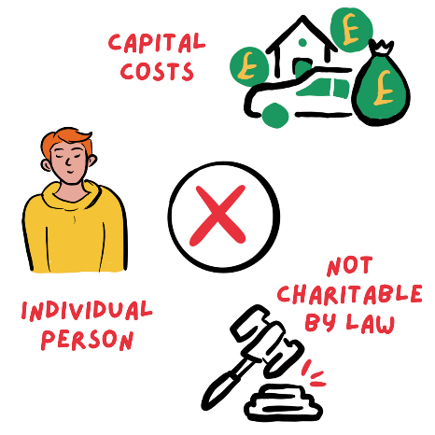 | We can’t fund:  - Work that is not seen as charity work by law  - Grants to individual people  - Capital costs
Capital costs: this is a payment to cover things such as building work, renovations, and equipment.
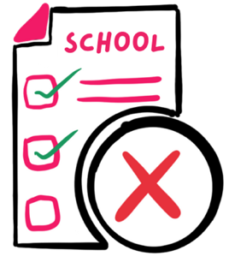 | We can’t fund these types of work:
 | - Work that is part of the school curriculum.
School curriculum: this means a list of everything that must be taught in schools across the UK.
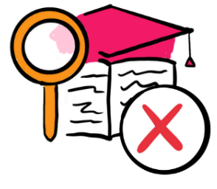 | - Academic research, unless you can show this will help solve a problem in society for example.
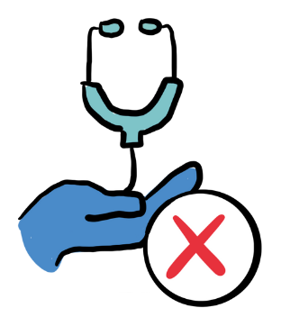 | - Healthcare which has a clinical base. This includes things like:  - Research on medicines  - Hospices (where people go when they don’t have long to live)  - Counselling and therapy  - Arts therapy  - Education about and treatment for drug and alcohol misuse
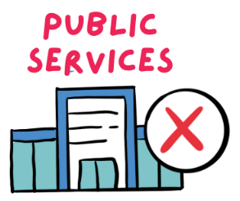  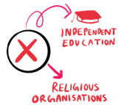 | - Work that local authorities and councils should be doing like social care  - Independent education like private schools  - Organisations that push for a religion

How we make decisions
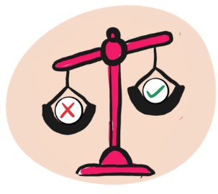 | To help us decide who to give money to, we think about these things:
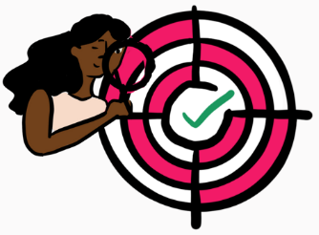 | - How good a match is an organisation’s work with what we want to fund.
 | - How well we think the organisation can do the work. That includes things like:  - how good the leadership team is  - if the organisation has good policies in place like safeguarding, and there are no big money problems  - if the organisation has the right people to do the work  - how good they are thinking about diversity, equity and inclusion. That means thinking about the fair treatment and rights of everyone, especially people from marginalised communities.
Marginalised communities means people from groups that are often not treated fairly, for example Black or Disabled people.
  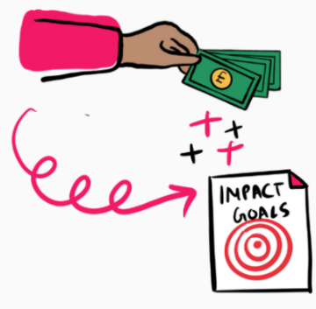 | We will think about the other work we fund and how could our money and support add to this work?  We will also think about how we can best use the money we have to support our impact goals?
Impact goal: this means the difference we want to make through our funding.
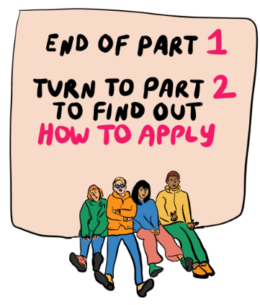 | This is the end of Part 1.  Please go to Part 2 now, to find out how to apply.
This document was put into Easy Read by the Empower Team at People First (Self-advocacy).
You can visit our website by clicking on this link:
www.peoplefirstltd.com
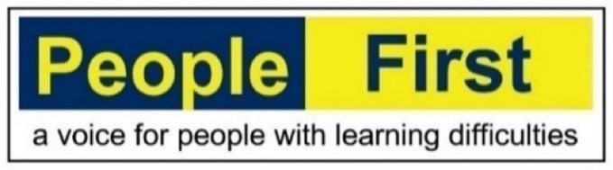
The illustrations were created by Malini Chakrabarty.
You can visit her website by clicking on this link:
www.artofbirdie.com
