Youth-Led Creativity Funding

Guide

Part 2

How to apply

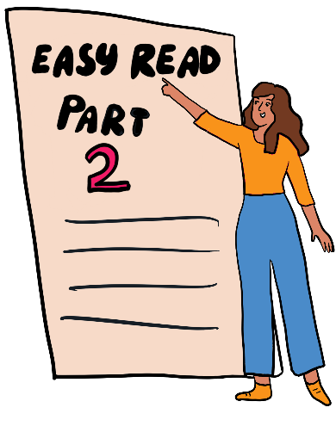
This is the Easy Read version

Youth-Led: this means work that is led by and for young people.
Fund or funding: this means money that we give to organisations to support them with their programmes.

About this document
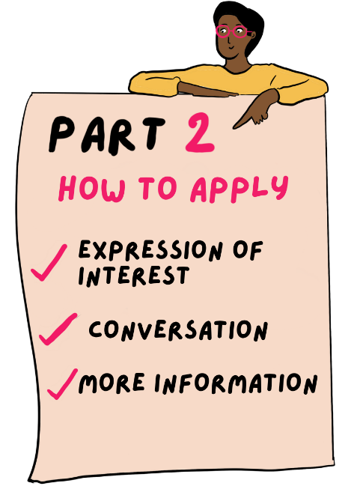 | This document is Part 2 of 2.  It covers the steps in the application process:  - Expression of Interest  - Conversation  - More Information  Please make sure you have read Part 1 first.

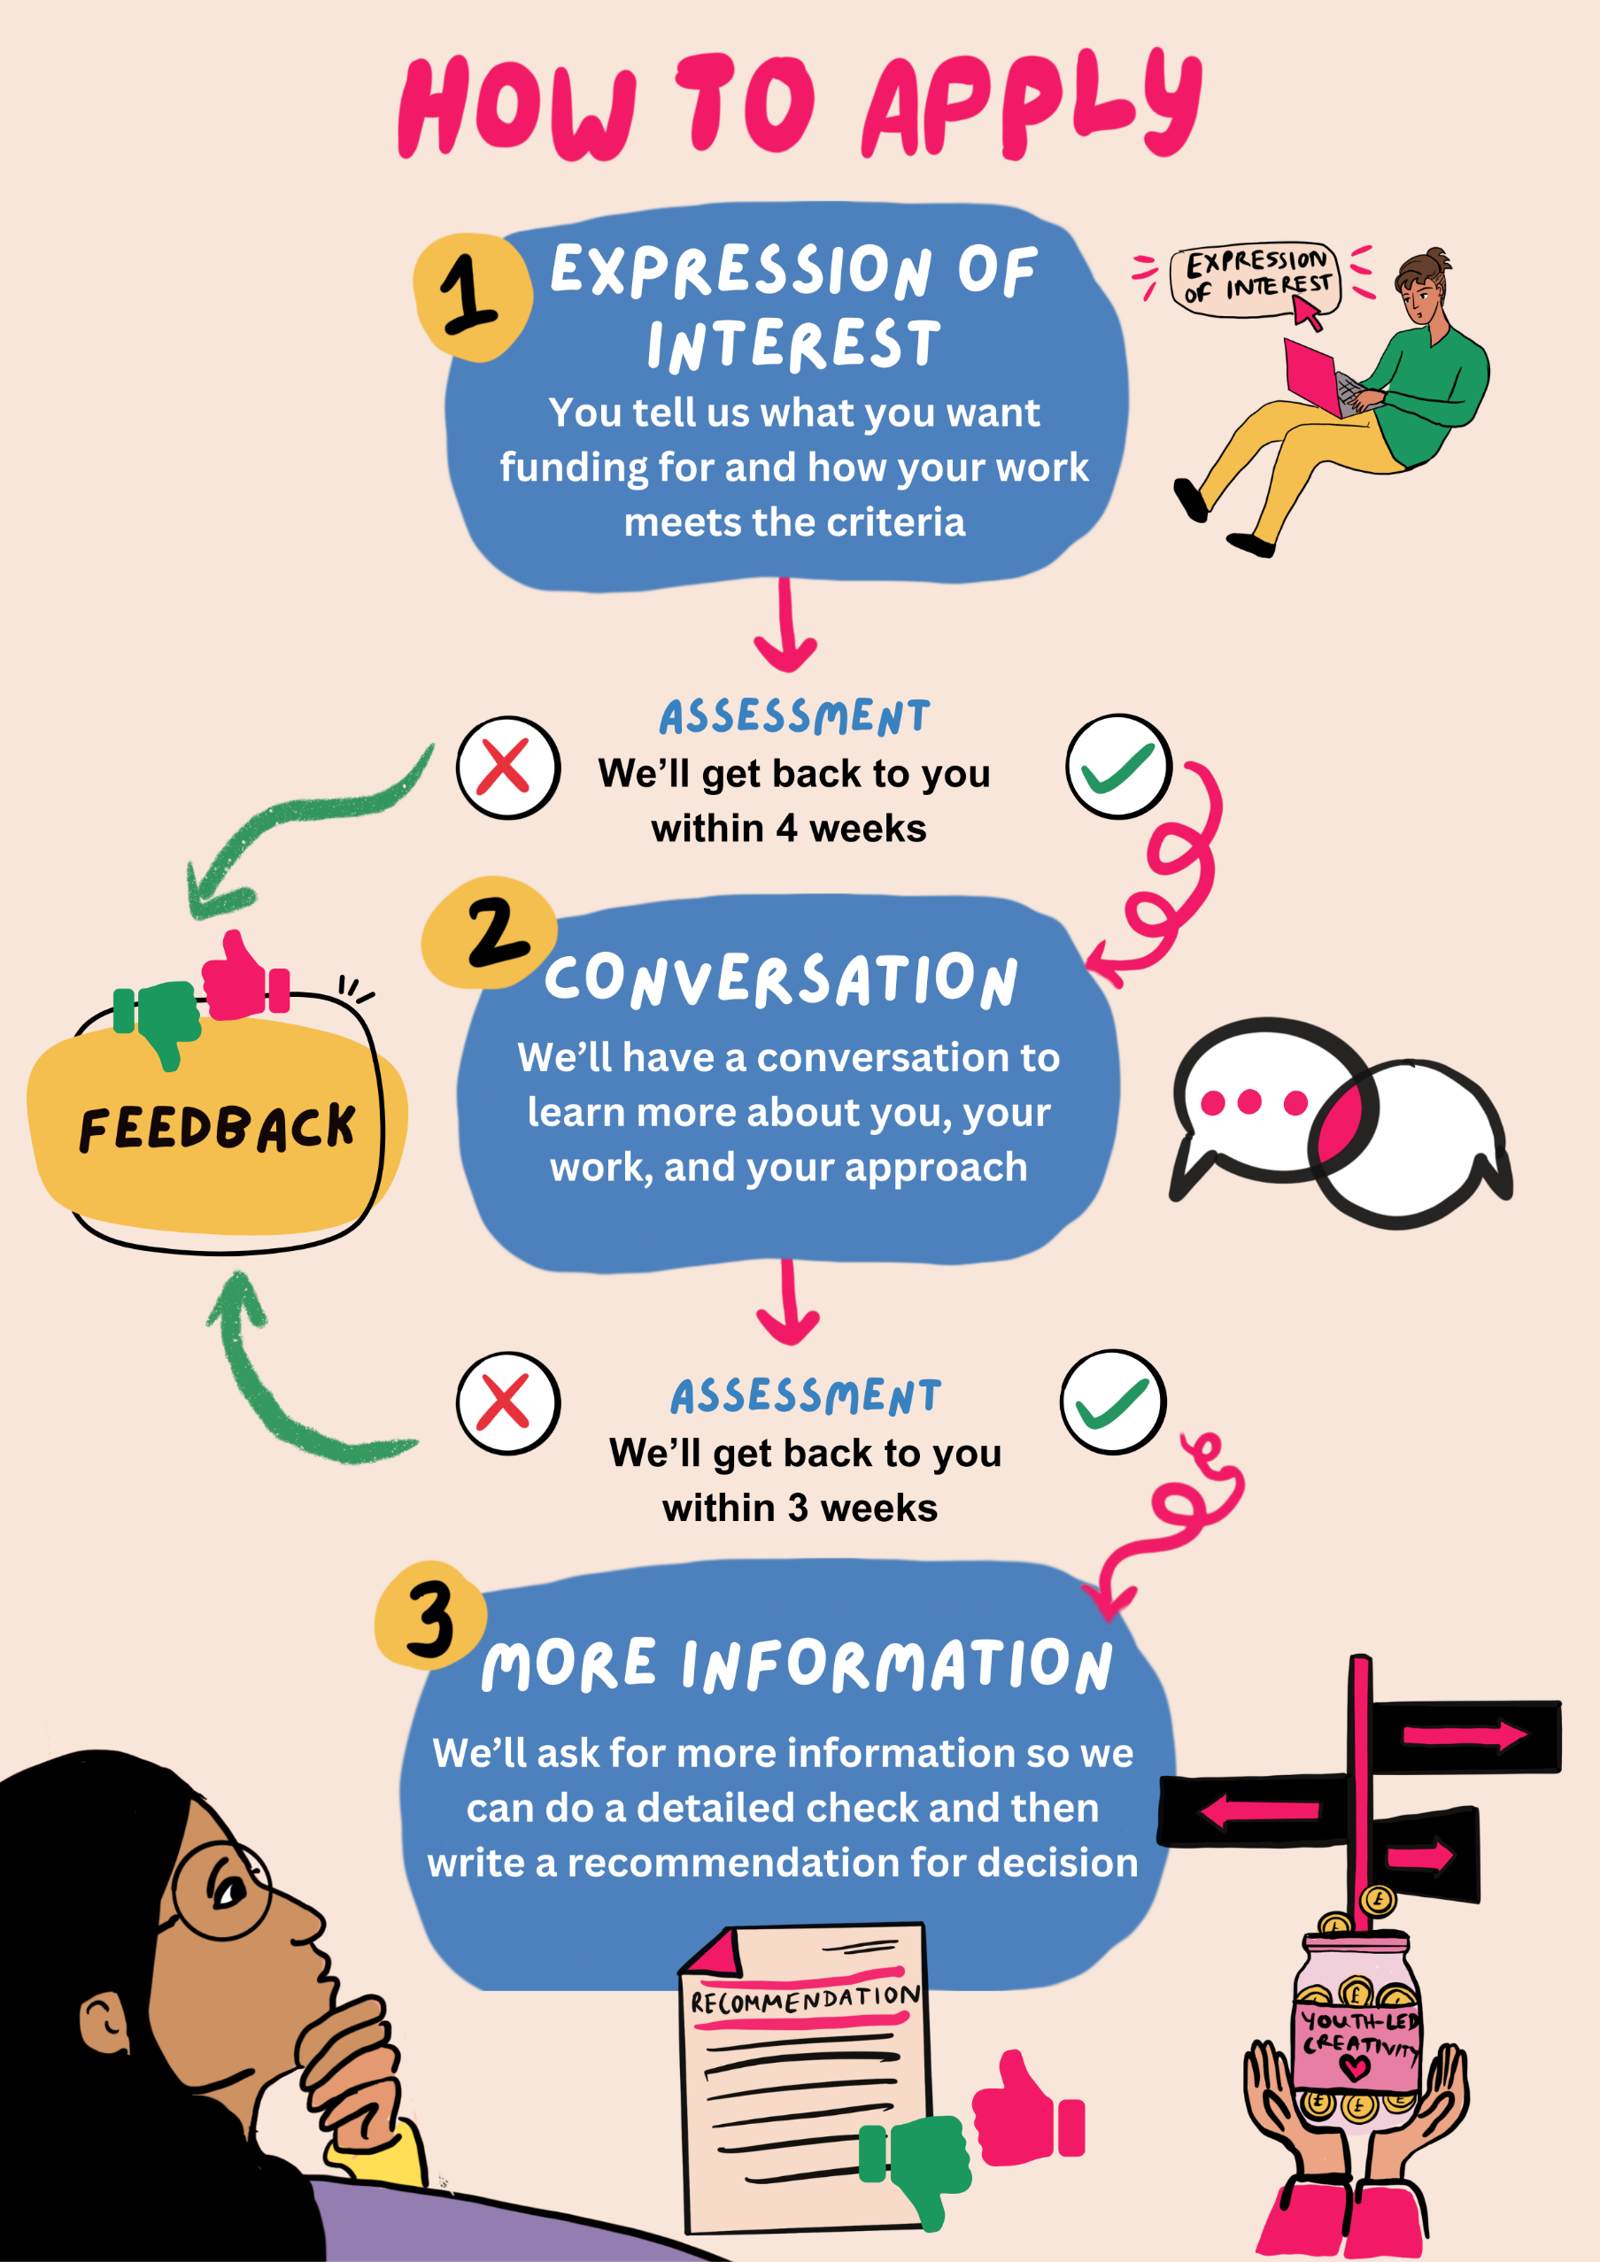

How to apply for funding
 | We accept funding applications all the time. It can take up to 6 months for us to process your application.
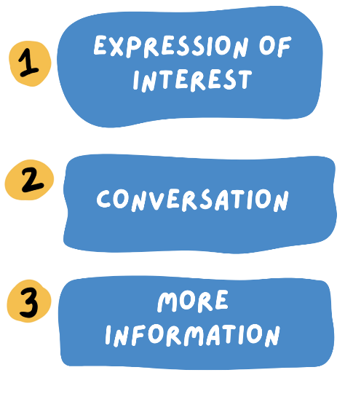 | There are 3 stages to apply for funding:  - Expression of Interest: You tell us about your work  - Conversation: We’ll have a call to learn more about you and your work  - More information: We’ll ask for more information so we can do a detailed check  We will make an assessment at each stage to decide which applications to take forward.
An assessment is a review of information.

Expression of interest
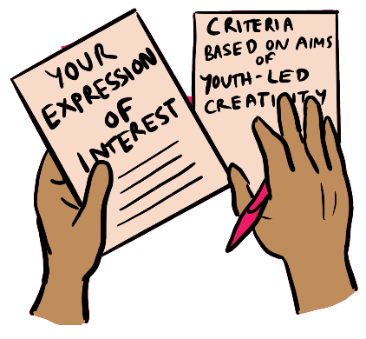  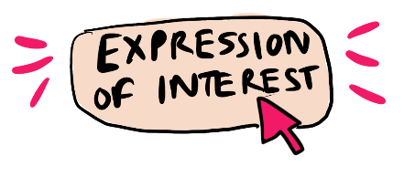 | This is the first stage. You tell us:  - That you want to apply for our funding  - About your work  You do this by filling in a form on our website.  Click here to go to the form.
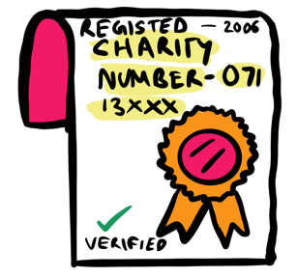 | In the form, we will ask you about:  - Your organisation  - Charity or company number
Charity or company number: this is a unique number that you get when you register your charity or company with the Government.
 | - Total income for the last financial year
Income: this means all the money coming into your organisation’s account
Financial year: this means a 12-month period where an organisation gets income.
 | - Number of trustees and non-executive directors
Trustees: this means members on the board of an organisation who have power to make important decisions
Non-executive director: this is a board member who advises the organisation but is not a staff member. They are part of the board of a company.
 | - The date that your organisation was set up
 | - Your organisation’s website and social media accounts.
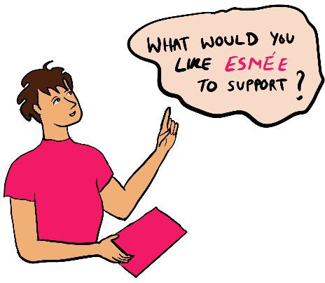 | - Your funding request  - The name of the work you’d like Esmée to support  - How much money you would like  - How many months of support you want.  Then we will ask you these 4 questions about your work:
 | - Tell us what you want Esmée to fund and why (You have 150 words for your answer)
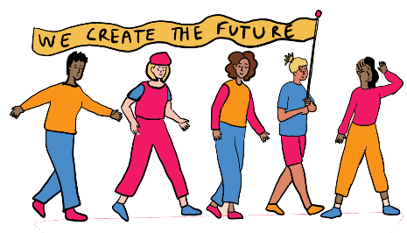 | - How do young people lead and shape your work? (You have 350 words for your answer)  We’re interested in the young people from communities that are not often included in arts and culture.
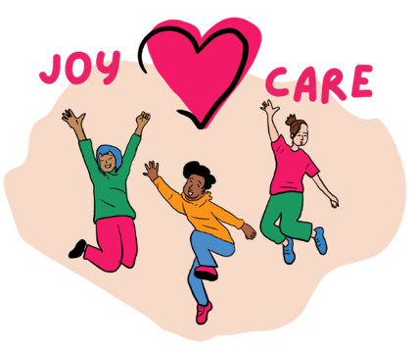 | - How do you put the joy and care of young people first? (You have 350 words for your answer)
 | - Tell us about a time you worked with other people or organisations to support youth-led work. What did you learn from this? (You have 350 words for your answer)
 | We will also look at your website. This will help us learn more about:  - your organisation and how you run it  - your work with young people  - the difference your work has made so far  You can add links to reports, videos or other useful information in the box on the form.
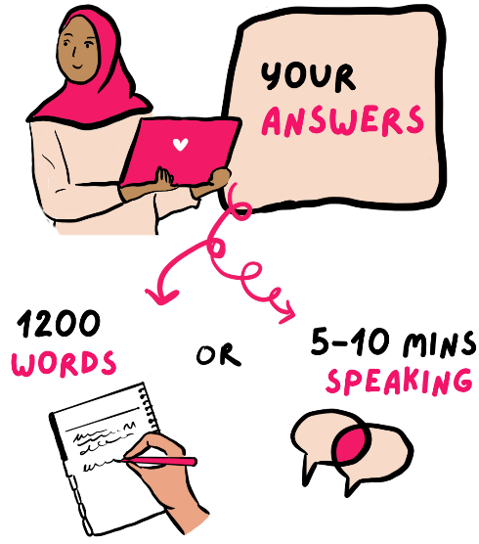 | You can answer these questions in 1 of 3 ways:  - Type your answers into the form online in no more than 1200 words.  - Record an audio of you speaking your answers.  - Record a video of you speaking your answers.  If you do the audio or video, it is about 5 to 10 minutes of speaking.
Giving us your answers in an audio or video recording
Making the recording
- Please answer each question in order.
- Say the question number before each answer.
We will only think about your answer. The quality of the audio or video recording does not matter.
Uploading your recording
You will need to upload your recording to any of the main file sharing websites.
If you upload a video, we suggest setting it to “Unlisted”. This means only people with the link can see it.
If your video has a password, send us the link first.
Then reply to the confirmation email with the password.
If you have problems uploading your recording files, please go to these links which will help you:
- Google Drive
- Dropbox
- YouTube
- Vimeo
- SoundCloud (for mobile app)
- Soundcloud (for website)
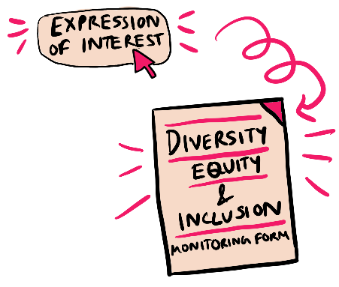 | Diversity, Equity and Inclusion (DEI)  After you send your Expression of Interest, we will ask you to fill in a Diversity, Equity and Inclusion monitoring form.  The monitoring form collects information about the people at an organisation and who they work with.
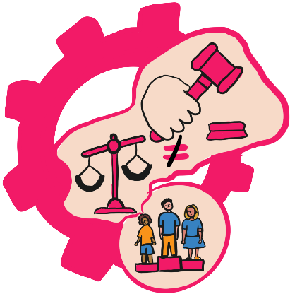 | This information helps us make sure that our funding is fair.  There is more information about our DEI work here.
Diversity means a mix of different kinds of people.
Equity means making sure everyone has everything they need to succeed and has access to justice.
Inclusion means making sure we include and value everyone.
Altogether, Diversity, Equity and Inclusion means trying to make sure that we treat people from all backgrounds fairly and they have the same chance to succeed.
  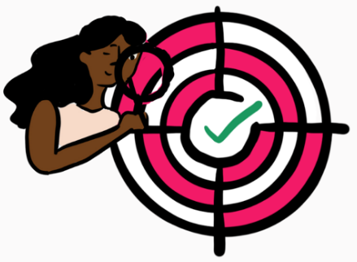 | What happens next?  We will review your Expression of Interest with our young consultants.  We will think about:  - Fit with our Youth-Led Creativity programme. How well your work matches the criteria.
 | - Your organisation´s leadership and experience. How well your organisation is run. The results from your work. If your organisation meets our conditions for funding. We will look at your website, social media, and reports to help us understand your organisation better
 | With our young people, we will decide if we want to take your application to the next stage.  We will tell you our decision within 4 weeks.
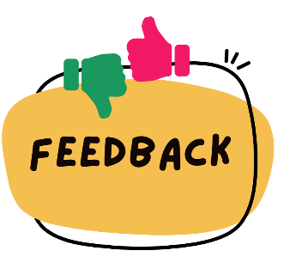 | If we decide not to take your application further, we will tell you why.

2. Conversation
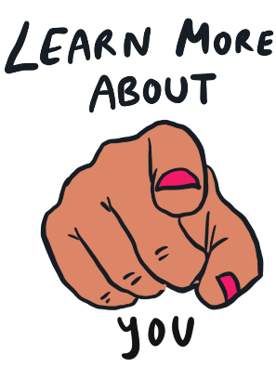  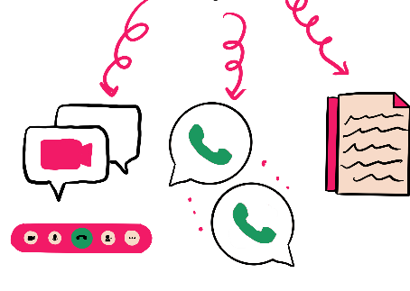 | After reading your Expression of Interest, if we think you might be a good fit for our funding, we will invite you for a Conversation.  This could be a video call or phone call.  Or, you can send us written information. This could be an email with your business plan or the answers to our questions.
 | What we will talk about:  - We will ask you more about:  - your organisation and work  - your networks and communities  - We will tell you more about the other work we fund  - You can ask us about our funding programme and how we can help your work
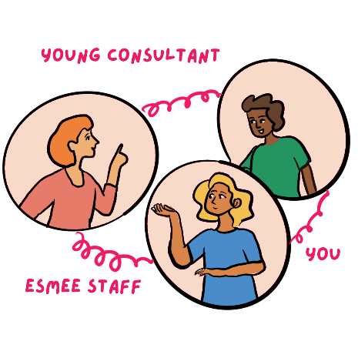 | About the call:  - It will last about 1 hour.  - It will be with an Esmée staff member and a young person from the funding programme.  - You should have no more than 3 people on the call.
 | More information about what we will talk about:
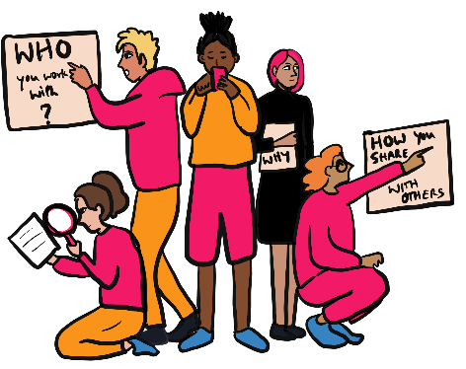   | - What you will do and who you will help  - How you know your work is making a difference  - How our support and contacts could help your work  - How you run your organisation and make decisions  - Your team´s skills, experience and time to do the work
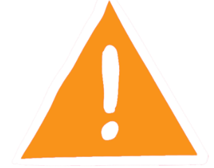 | - What are the risks of doing this work and how will you manage them
 | - Young people:  - How they lead the work, including how arts and creativity help them lead  - How you support their wellbeing, joy and safety  - How you pay them for their time and leadership
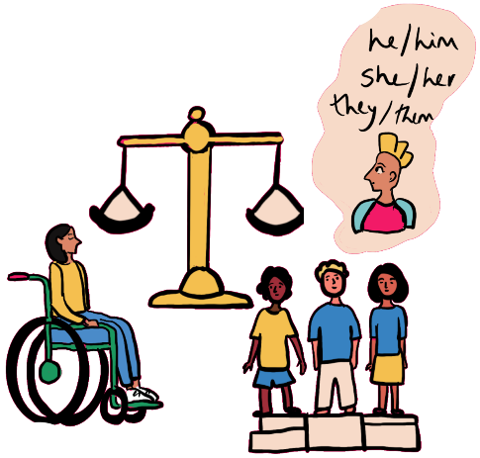 | - How you support diversity, equity and inclusion  We will ask about how you push for these things in your organisation and through your work.
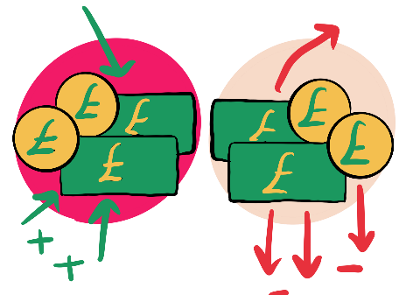 | - Your organisation´s funding and finances
 | What happens next after the call?  We will write notes about the call and talk about your application with our young people. Then we will decide if we want to take your application to the next stage.
 | We will tell you our decision within 3 weeks of your call.
 | If we decide not to take your application further, we will tell you why.

3. More information
 | If we take your application further, we will ask you for more information. This will include:  - Any more questions we have about your work
 | - Information about your organisation’s finances
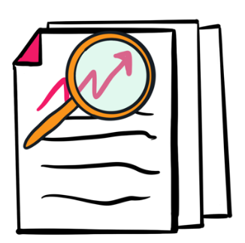   | - Up to 3 outcomes you expect from the work. Outcomes means the results that our funding can lead to. These outcomes should add to Esmée’s aims for the programme.  Click here to find out more information about outcomes: guidance on outcomes for more information
 | - Documents to support your application, such as your:  - Latest annual report and accounts.
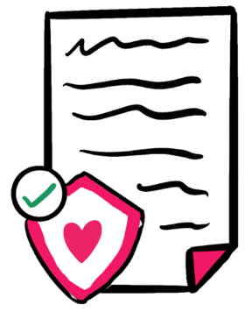 | - A copy of your safeguarding policy.  You can read more about our work around safeguarding by clicking on this link:  Our approach to safeguarding
Safeguarding policy: this means a document that sets out rules around keeping people safe. This means people in your organisation and people you work with.
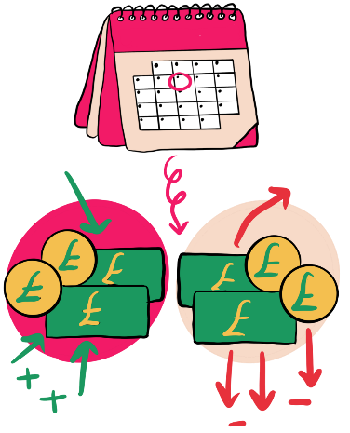 | - An income and expenditure budget for the organisation. This is for the financial year that is happening now
 | - If you are applying for a project, we will ask for a budget.  This budget should show us what you want us to fund. It should tell us if you have applied for any other funding. Or, if you are getting any other funding.
 | - Your organisation’s rules, if you are not a registered charity. This could be your Constitution or Memorandum and Articles of Association.  Or, a copy of other rules if you are not a registered charity.
Constitution, Memorandum and Articles of Association: this means written rules about running an organisation. It sets out an agreement by law for all the people who are part of running the organisation.

What happens next?
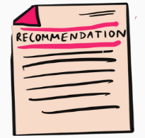 | Esmée staff and our young people will review all the information.  They will talk about your application at a meeting with other funding requests. Then they will recommend a decision.
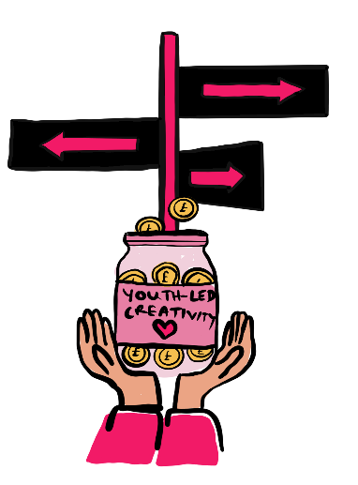 | This is who makes the final decision:  - Esmée’s Management Team - for grants up to £120,000 (1 hundred and 20 thousand pounds)  - Esmée’s Management Team and Trustees – for grants up to £300,000 (3 hundred thousand pounds)
You can read more about our teams by clicking on these links:
Trustees
Management team
 | We will make a decision in 2 to 3 months.
 | If you are not successful, we will tell you why
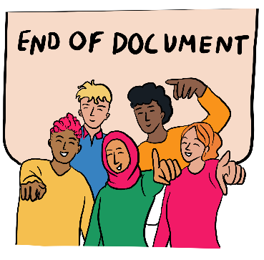 | This is the end of the document.
This document was put into Easy Read by the Empower Team at People First (Self-advocacy).
You can visit our website by clicking on this link:
www.peoplefirstltd.com

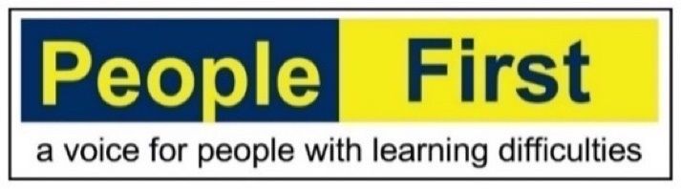

The illustrations were created by Malini Chakrabarty.
You can visit her website by clicking on this link:
www.artofbirdie.com

